Ice Storm January 24-26, 2026

By: Don Wheeler, Meteorologist

A major ice storm struck north Louisiana and adjacent states January 24 through the 26 with devasting effects. Significant icing downed numerous trees, branches, powerlines, and utility poles resulting in extended widespread power outages. Damage to structures also occurred either due to fallen limbs and trees as well as a direct result of the weight of the ice on roofs. This historic winter weather event was so destructive that it forever changed the existing landscape.

Cold Arctic air pushed into the region during the day of January 23 with freezing temperatures arriving during the early morning hours of January 24. The system arrived in two distinct waves in the form of upper-level disturbances that followed the arrival of the Arctic air. A large and powerful upper low was spinning off the northern Baja California peninsula which contributed to abundant moisture being advecting across northern Mexico, across Texas, and eventually into our region.

The first upper disturbance pushed across north Louisiana during the day of January 24 producing a combination of sleet and freezing rain. Much of the onset of the precipitation was sleet; however, that quickly changed over to moderate to heavy freezing rain. Limbs and power lines quickly became weighed down with significant ice accumulations soon after the changeover to freezing rain resulting in numerous power outages by midday of the 24th.

The disturbance quickly exited the state by the afternoon of January 24; however, another more potent disturbance was on its heels. This disturbance arrived during the overnight hours of January 24-25 dealing a devasting blow to much of north Louisiana, especially along the I-20 corridor. The second system brought storm total liquid equivalent amounts exceeding 3-inches in some locations.

Following the precipitation event, another surge of very cold air plummeted southward behind the departing upper-level system. Temperatures dropped into the upper teens to lower 20s on the night of the 26th and morning of the 27th making for additional hardships for those without heat due to power disruptions.

Synopsis and Overview

During the week leading up to the ice storm, long-range models were strongly indicating the event. In many cases when these models begin to indicate such an event, caution is used because of inconsistencies with long-range forecasting. In this case, however, both the GFS and EURO models were persistent in bringing a significant winter storm to much of north Louisiana and adjacent areas. At question early on was the type of precipitation and how much; but, frozen precipitation was a certainty.
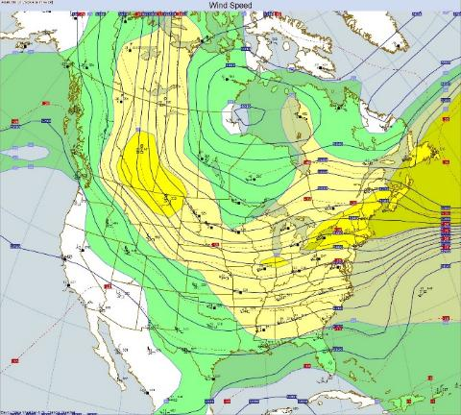
Much of the eastern U.S. was under the influence of a large-scale upper trough that had been allowing waves of cold Arctic air to push south and southeast. With time, the air across our region was becoming increasingly colder.

At 1:20 PM on January 20, the National Weather Service in Shreveport issued a Winter Storm Watch for its County Warning Area which included northwest and northcentral Louisiana. By early afternoon on January 21, Winter Storm Watches had expanded east and south to include all north Louisiana as well as portions of southwest and southcentral Louisiana.
Figure 1 – Upper-Level Chart 12Z 1/21/26

On January 22, Louisiana Governor Jeff Landry declared a state of emergency for all of Louisiana in preparation for the impending winter storm event (see attached document in the appendices).

Sunday, January 23

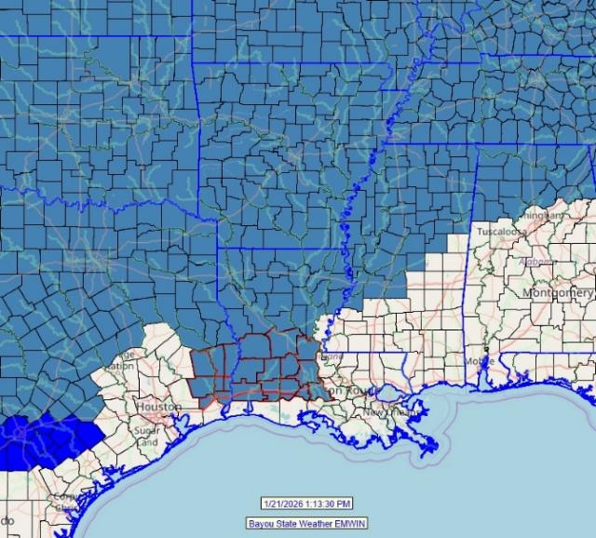
The stage was set for an impending major ice storm across north Louisiana. Forecasts called for ice accumulations (freezing rain) of ½ to 1-inch across much of north Louisiana through Sunday afternoon. In addition, another ½ to 1-inch of sleet would be possible. A Winter Storm Warning had been issued for northwest and northcentral Louisiana along the I-20 corridor with an Ice Storm Warning for northeast Louisiana along and north of the I-20 corridor.

Surface map analysis for Friday morning, January 23 depicted an Arctic cold front stretching from low pressure over northern New York southeast across Pennsylvania, West Virginia, central Tennessee, across central Arkansas, and southern Oklahoma north of the Red River. Very cold air was behind the front being funneled in due to a massive 1051mb/31.04” high over the Montana/North Dakota border.
Figure 2 - Winter Storm Watches 1/21/26 at 1PM CST

In the upper levels, a powerful upper low was spinning off the northern Baja California peninsula. Abundant moisture was riding around the base of a large upper trough and around the upper low advecting across northern Mexico and into Texas. This moisture pushed east out of Texas and into our region and continued through the weekend.

The front pushed south during the day of January 23 with temperatures slowly dropping overnight. Freezing temperatures did not arrive until the early morning hours of January 23 and were along and just south of the I-20 corridor. The first upper disturbance pushed into the state late Sunday night and early Saturday morning.

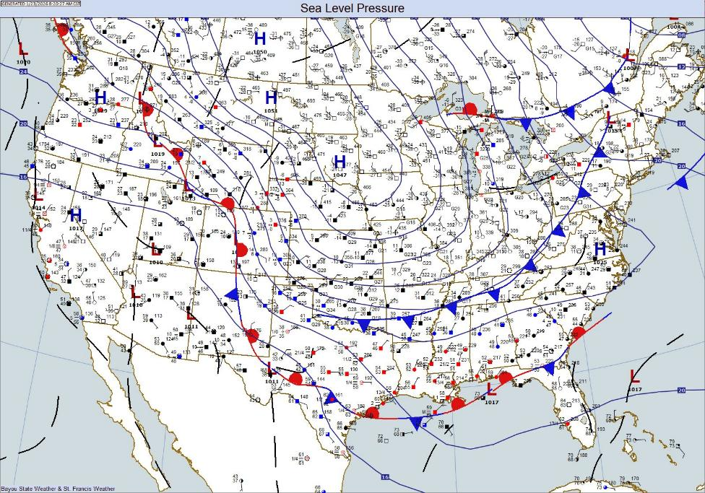
Figure 3 - Surface Map 8AM 1/23/26 Showing Approach of the Arctic Cold Front

Saturday, January 24

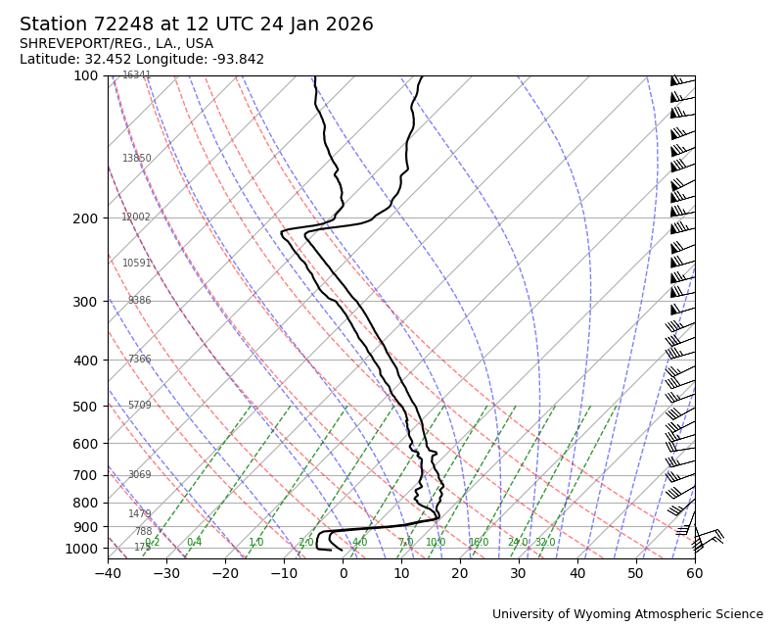
During the morning hours of January 23, freezing temperatures were along and just south of the I-20 corridor. Precipitation was initiating with the arrival of the first upper disturbance moving east out of Texas. Numerous reports of sleet and freezing rain were incoming with the system across east Texas and northwest Louisiana.

Upper air data from the Shreveport National Weather Service at 12Z (6AM CST) on the 24th, indicated a classic set up for freezing rain and sleet. Temperatures at the surface were below freezing with a sharp inversion layer at around 925mb. This is also the level where abundant low-level moisture was present. Temperatures aloft were above the freezing mark at the 900mb level or around 2600 feet indicating the cold air was very shallow.
Figure 4 - Upper-Level Sounding from KSHV showing shallow cold air at and just above the surface with saturation.
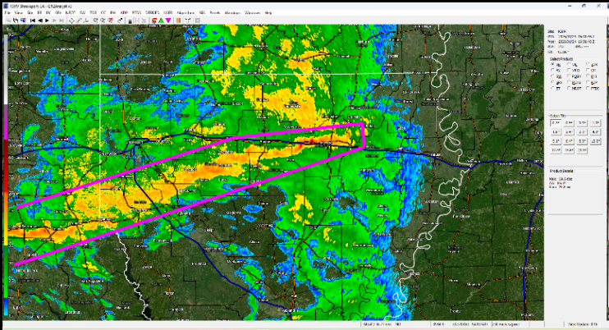
The precipitation quickly spread east and intensified as it pushed across north Louisiana. Of particular interest was a narrow band of heavy sleet that extended from eastern Ouachita Parish west-southwest to between Shreveport and Mansfield. This band dropped heavy amounts of sleet from ½ to over 1-inch in a just a few hours.
Figure 5 - Area of Heavy Sleet and Freezing Rain at the Onset of the Event 1/24/26 at 1631Z (10:31 AM CST)

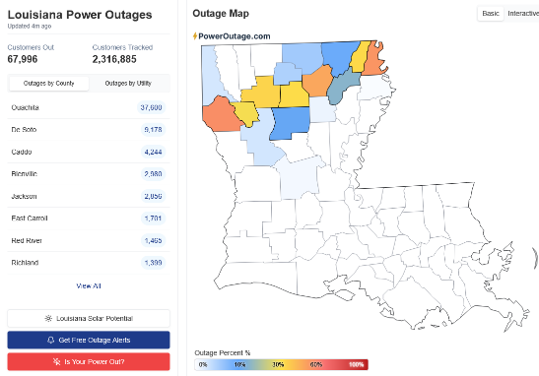
After dumping heavy amounts of sleet, the sleet quickly transitioned over to moderate to occasionally heavy freezing rain. It was at this time significant icing began across north Louisiana. Tree and powerline damage shortly followed the onset of the freezing rain.

In the radar image above, note the location of the heavy band of precipitation in the radar image compared with the associated power outage map. This was the zone of highest ice damage during the event. According to PowerOutage.com by 9PM nearly 68,000 customers in Louisiana were without power, 37,600 of which were in Ouachita Parish alone. The most numerous power outages were across the western portion of Ouachita parish.
Figure 6 - Initial Power Outage Map Following the First Round of Precipitation. Compare with the Radar Image in Figure 4.

By afternoon, much of the precipitation had come to an end across north Louisiana; however, the more potent upper-level disturbance was quickly pushing east and northeast out of south Texas and northeastern Mexico. Precipitation began again during the evening hours Saturday with even some light snow falling in some areas.

January 25

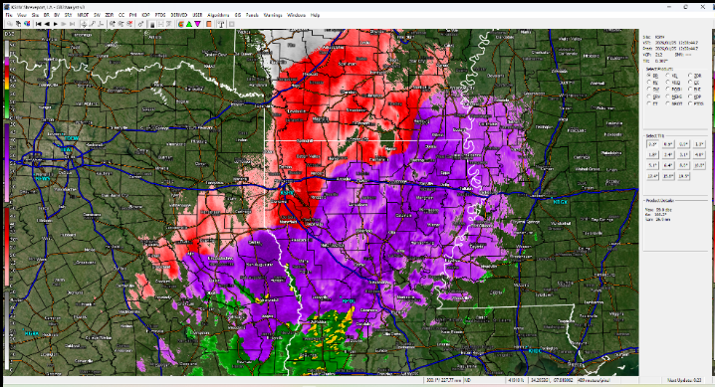
The primary upper disturbance pushed across our state Saturday night/Sunday morning of January 24/25. A large mass of mixed precipitation spread from southwest to northeast. The atmosphere was so unstable with this second disturbance, that many locations experienced thunder-sleet, thunder-snow, and thunder-freezing rain! By the time the second disturbance arrived, the cold air had penetrated much farther south and was affecting northern areas of south Louisiana. An observer in Avoyelles Parish reported, “Thunder, ice, sleet, and snow flurries since 3:30 AM.”
Figure 7 – Enhanced Radar Image from KSHV at 1208Z (6:08 AM CST) 1/25/26
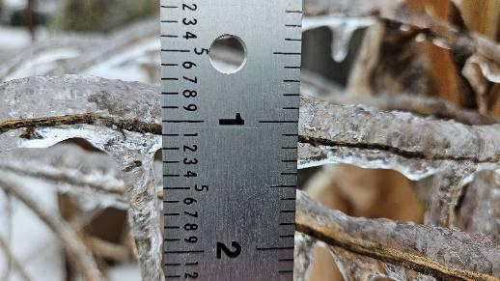
Figure 8 - Ice Accumulation on Small Twig in Ouachita Parish
The additional heavy precipitation, most in the form of freezing rain, only exacerbated a bad situation, especially in areas struck by the earlier round of precipitation. Heavy liquid equivalent amounts fell along the I-20 corridor. CoCoRaHS station Swartz 2.0 SW in Ouachita Parish reported 3.44” of liquid precipitation (that included melted frozen precipitation) with 1.7” of ice on flat measuring surfaces. All that 3.44” amount fell when temperatures were below freezing. Precipitation fell across all north, central, and southwest Louisiana during the overnight hours. The precipitation shield began to end generally from west to east around dawn and pushing out of north Louisiana and into Mississippi around 9AM on the 25th.

Total freezing rain and ice accumulations varied across north Louisiana dependent on the type and duration of precipitation that fell. Storm data from the National Weather Service in Shreveport indicated that one to six-inches of sleet accumulated across north Louisiana with the highest concentration along and south of the I-20 corridor of northwest Louisiana. Additional ice accumulations were in the ½ to 1-inch range from near Mansfield and Coushatta northeast across the Monroe area to Oak Grove.
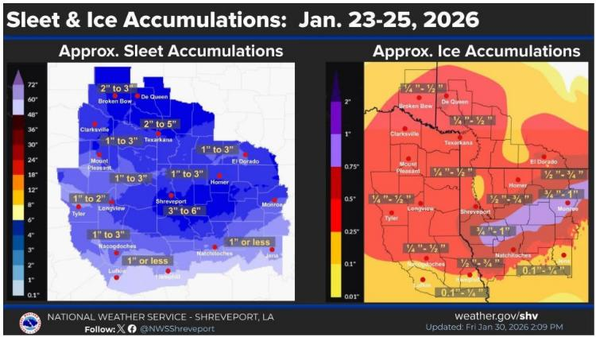
Figure 9 - Total Sleet and Ice Accumulation across North Louisiana from the National Weather Service in Shreveport
Satellite imagery taken early on January 27 after the clouds departed shows the extent of the ice across north Louisiana and adjacent areas.
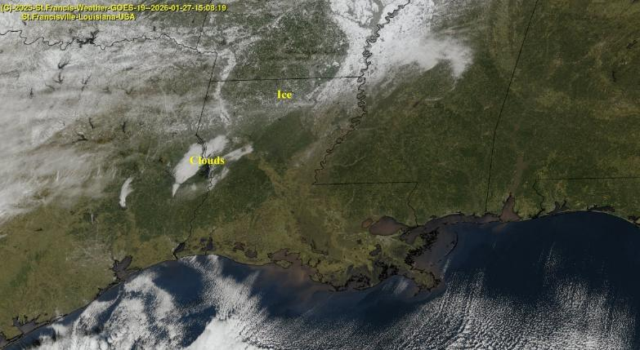

Figure 10 - Satellite Imagery of Ice across North Louisiana and Adjacent Areas on 1/27/26 at 1508Z (9:08 AM CST). Courtesy of St. Francis Weather
Impacts

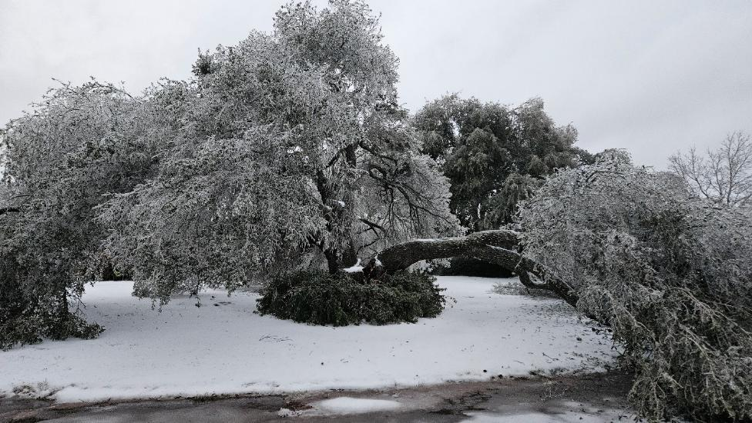
Figure 11 - Ice Ladden Trees Common across All of North Louisiana
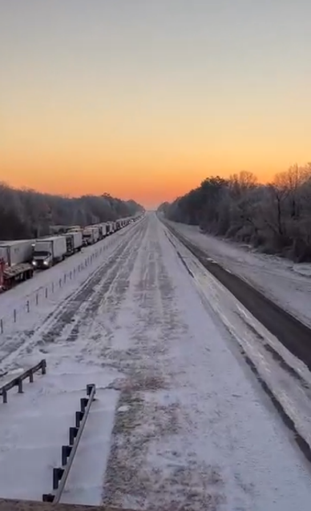
Due to the combination of heavy sleet accumulation and heavy ice accumulation from two rounds of winter weather, widespread tree damage occurred across much of north Louisiana resulting in excessive power outages where in some cases residents were without power for over a week. Although much of the precipitation had ended by noon on the 25th, tree and powerline damage continued to occur into the next day. In addition to tree and powerline damage, structural damage also occurred either due to trees falling on structures or simply from the weight of the ice. Metal structures, such as storage buildings, were more prone to damage due to ice accumulation.
Figure 12 - Traffic Backup on I-20 (Courtesy KSLA TV)

Severe icing of I-20 was responsible for a massive traffic backup stranding hundreds of motorists for several hours up to two days. The jam stretched for nearly 40 miles between Minden to just west of the West Monroe area of Ouachita Parish. The backup was caused by disabled 18-wheelers in conjunction with the icing. Once stalled, trucks could not climb hills due to the lack of traction on the black ice. Meals and other assistance were provided along the route by the Louisiana Department of Transportation, Louisiana State Police, and the Louisiana National Guard.

Senators Bill Cassidy, M.D. and John Kennedy along with Congress Members Mike Johnson, Steve Scalise, Troy Carter, Clay Higgins, Julia Letlow, PhD, and Cleo Fields. drafted a letter to President Trump on February 10 in support of Governor Landry’s request for expedited federal Major Disaster declaration for the State of Louisiana (full letter is in the appendices).

The Governor requested public assistance including direct federal assistance, snow assistance, and Hazard Mitigation for Bienville, De Soto, East Carroll, Franklin, Morehouse, Ouachita, Richland, Tensas, and West Carroll Parishes. As of the February 10 letter, the State of Louisiana had incurred over $11,394,460 which meets the threshold for Disaster Declaration. The letter also included both individual assistance and business assistance for select parishes. Damage assessments and estimated costs incurred, however, are incomplete as of the writing of this document.

The scope of power line repair was monumental, not only for Louisiana but for many areas of the southeast U.S. The regional power outage map shown below indicates the general path of most severe icing extending from northeast Texas, across north Louisiana, then northeast across northern Mississippi, central Tennessee, and southeastern Kentucky. North Louisiana and north Mississippi were some of the hardest hit by the system. Utility companies from neighboring states were deployed well in advance; however, given the severity of the storm, restoration times were extended.

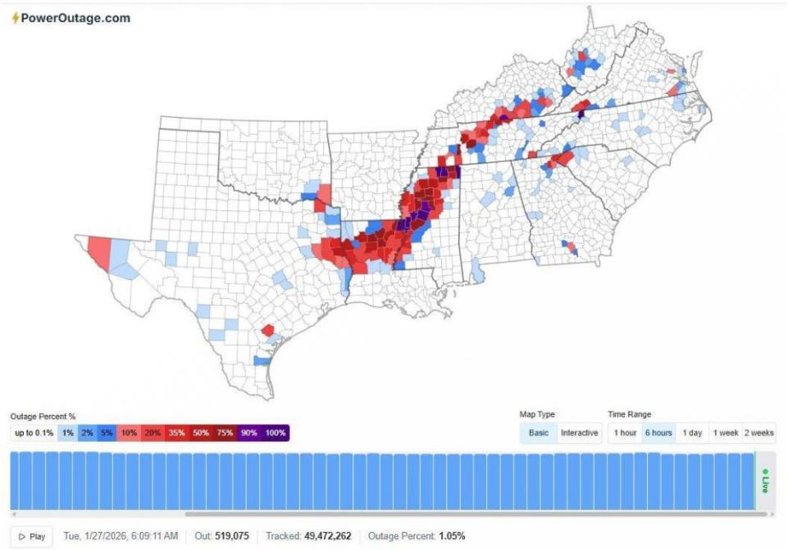
Figure 13 - Outage Map from PowerOutage.com Showing Large Swath of Outages from Northeast Texas into Southeastern Kentucky. Tuesday, January 27, 2026, at 6 AM CST.

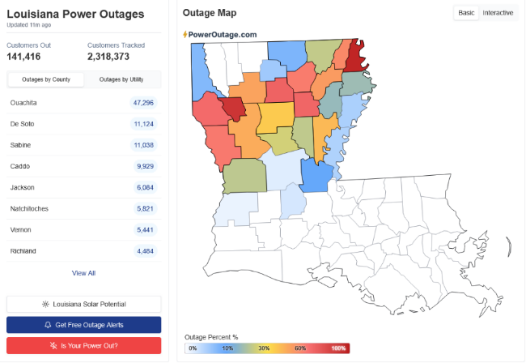
According to Entergy, some 4,400 personnel as part of the restoration workforce. Northeast Louisiana alone was estimated to have 91,500 Entergy customers without power at its peak, most in Ouachita Parish. Entergy replaced some 1,000 utility poles, more than 500 miles of wire, and 210 transformers, restoring power to around 130,000 customers – some of which were repeat restorations due to continued damage during and after the event.

As of January 25, at 1PM CST, PowerOutage.com reported 141,416 customers were without power across the state. This report includes both Entergy and non-Entergy customers. Ouachita Parish had 47,296 customers without power.
Figure 14 - PowerOutage.com Map as of 1 PM CST 1/25/26

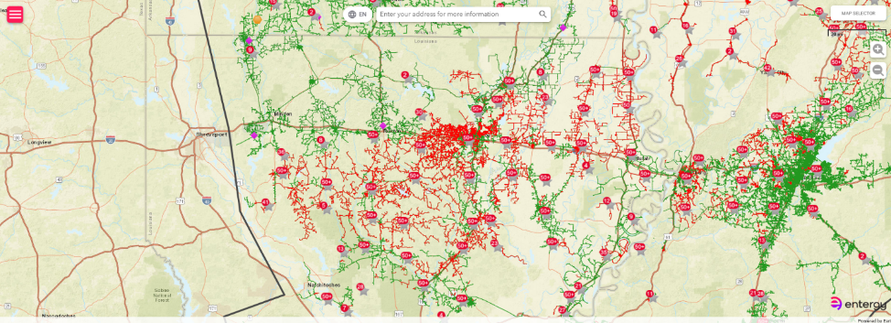
Figure 15 - Entergy Outage Map as of 1PM CST on January 25, 2026
While Louisiana is not a stranger to ice events, some are more notable than others. Comparative ice storms would include the January 5-13, 1973, event that affected north Louisiana and south Arkansas and the more recent February 9-13, 1994, ice storm that affect northeast Louisiana and southeast Arkansas. According to Louisiana State Climatologist Jay Grymes, “This storm is destined to rank among the top three to five most significant ice events in regional history.” Grymes also compared it to the January 1973 ice storm which longtime residents refer to as the benchmark for severe freezes. As one who personally experienced the 1973 event, this writer agrees.

Summary

January 23-26 saw a devasting winter storm composed of sleet and freezing rain strike portions of the southcentral U.S. The most concentrated areas of impact extended from northeast Texas across north Louisiana, then northeast to include southeast Arkansas, northern Mississippi, central Tennessee, and into southeast Kentucky. The storm’s impact resulted in widespread, massive tree and powerline damage across the aforementioned areas as well as some structural damage to homes and storage buildings due to either fallen trees, tree limbs, and/or the weight of the ice.

Extensive damage to utility infrastructures also occurred, especially to power and cable services. Entergy estimates that power was disrupted to over 91,000 customers with around 130,000 repairs due to repeat outages. PowerOutage.com reported 141,416 customers without power as of 1PM on January 25 which also includes non-Entergy customers. Entergy replaced some 1,000 utility poles, more than 500 miles of wire, and 210 transformers.

In Ouachita Parish, estimates as of early February show that 7, 542 business and their 122, 943 employees were impacted due to the ice storm’s multi-faceted assault.
- Power outage and other utilities
- Business damage
- Lost inventory
- Patrons unable to drive due to icy roads, downed trees and power lines
- Employees not able to drive due to icy roads, downed trees and power lines

Additional financial impacts to businesses as well as utilities, such as water, sewage, and cable, include costs due to overtime pay, equipment rental, and damage.

The United Way of Northeast Louisiana established a disaster relief fund to help Northeast Louisiana families impacted by the ice storm. They reported that more than 10,000 requests for assistance were received for assistance that include:
- Grocery/Food
- Utility Support
- Household Essentials
- Gas/Fuel
- Rent/Mortgage
- Emergency Home Repair

This event will go down in the record books as perhaps one of the top five winter storms in the state’s history. It has been compared to a benchmark ice storm that struck north Louisiana in January 1973 which also caused widespread and extended power outages along with extensive tree damage. Recovery and cleanup efforts will continue several months following this event with costs well into the millions of dollars. Perhaps, arguably, damage from the winter storm rivaled that of a healthy category one hurricane.
Disaster Declaration

On February 19, President Trump approved Major Disaster Declaration for nine parishes in north Louisiana. They include Bienville, De Soto, East Carroll, Franklin, Morehouse, Ouachita, Richland, Tensas, and West Carroll Parishes.

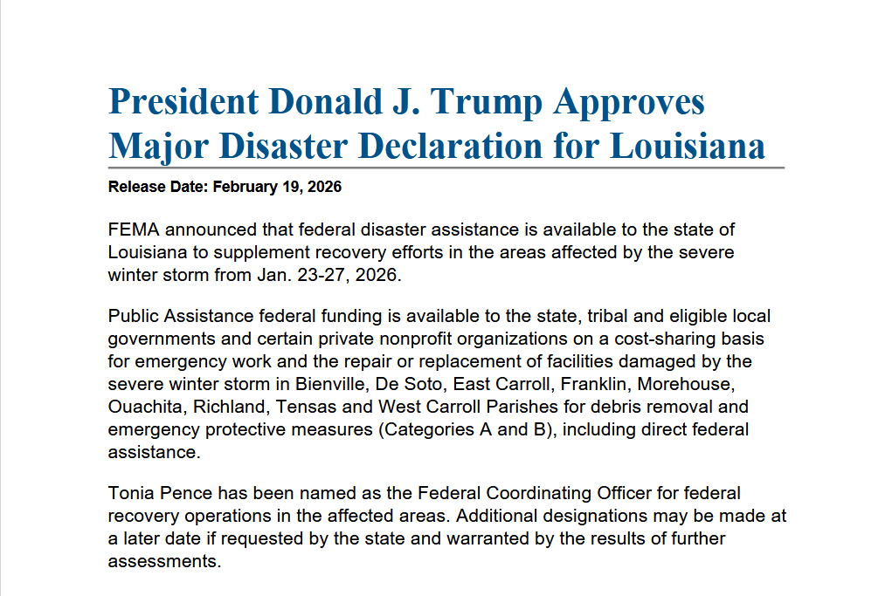
Figure 16 - Press Release from FEMA Announcing Major Disaster Declaration

Supporting Images and Documents/Appendix

Tree Damage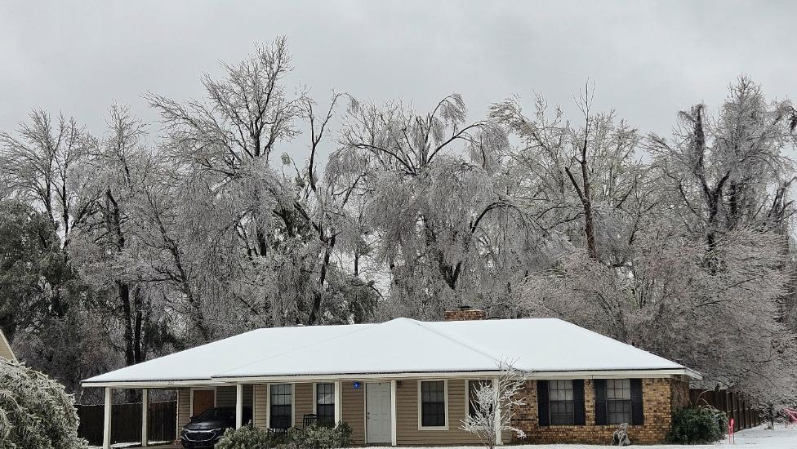

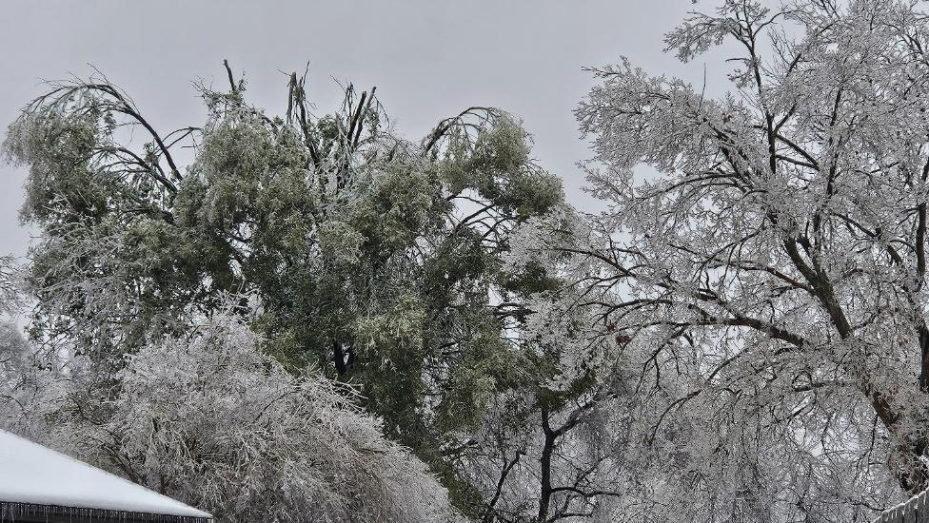

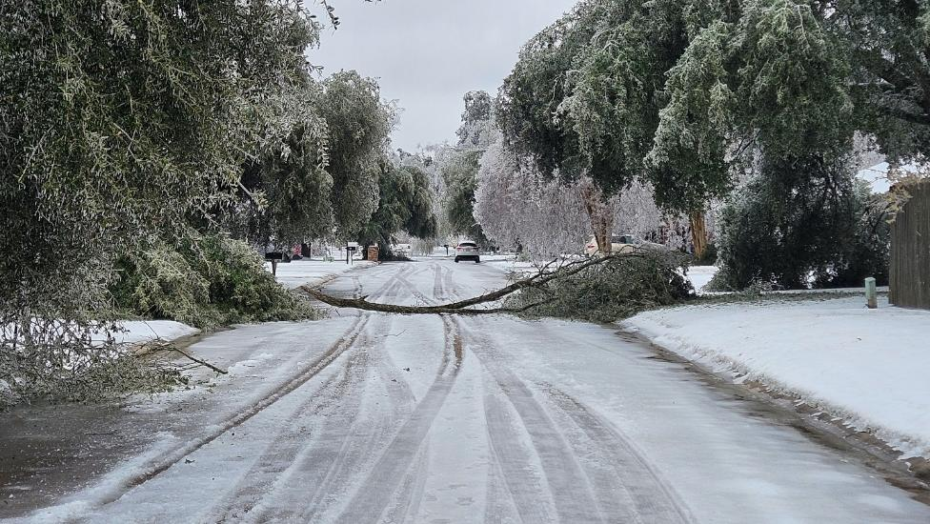

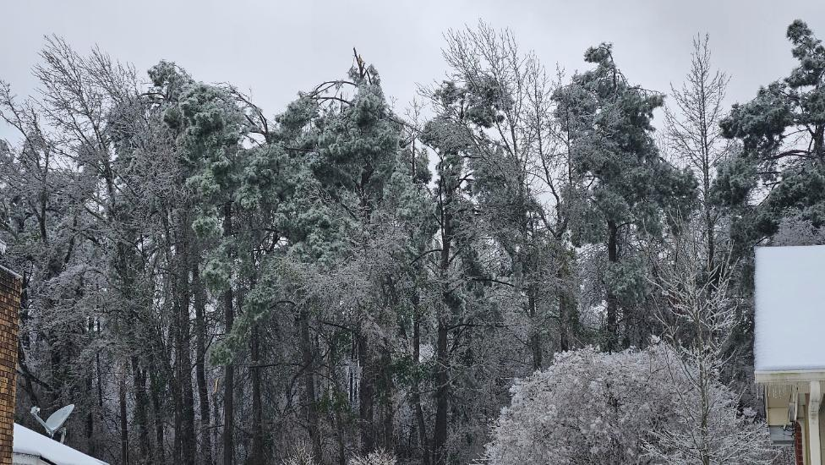

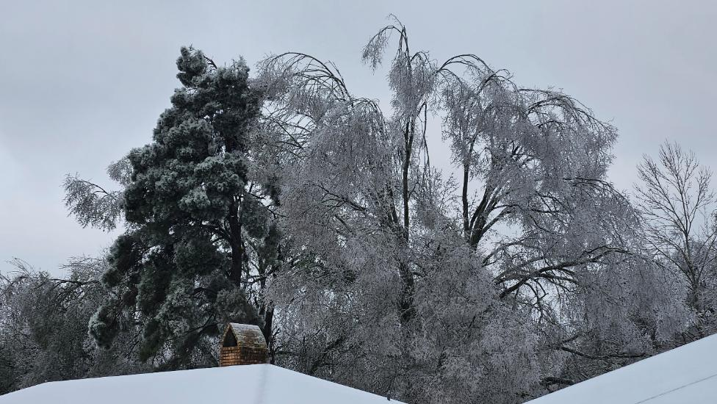

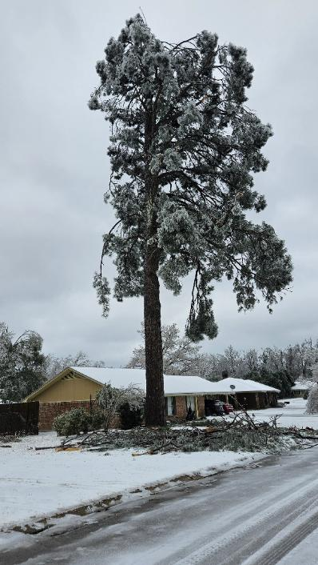
Aerial Images Below are Courtesy of Burt Green/WeatherUP (https://www.facebook.com/BurtGreenWX)
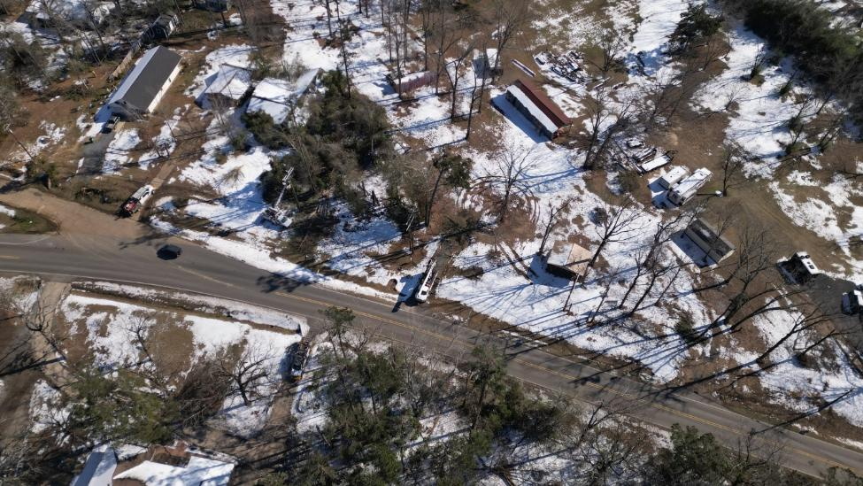

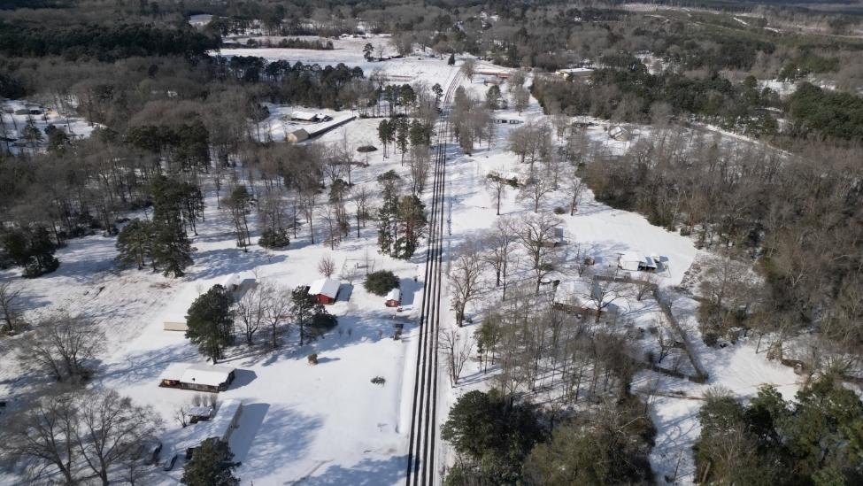

Maps & Charts

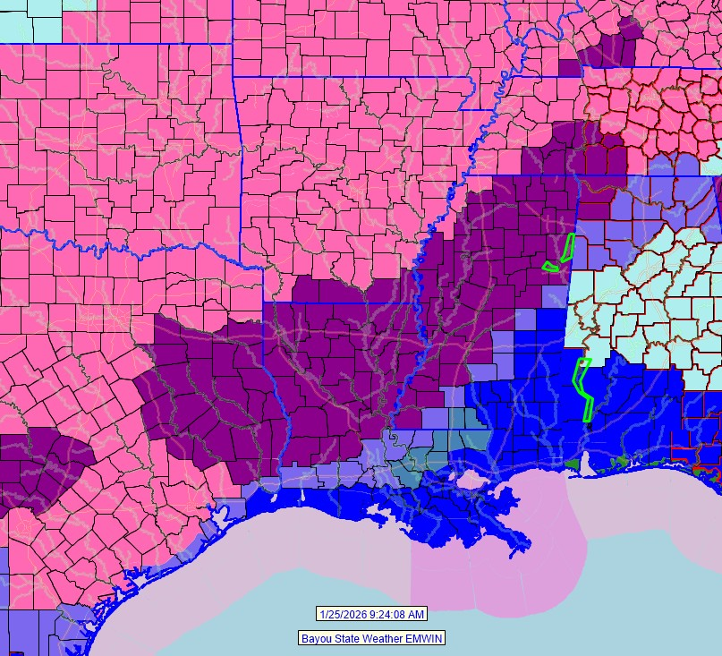

Winter Weather Advisories as of 1/25/26 at 9:24AM
Pink – Winter Storm Warning
Purple – Ice Storm Warning
Light Blue – Winter Weather Advisory
Steel Blue – Winter Storm Watch
Dark Blue – Extreme Cold Warning

Surface Maps for 8AM CST 1/23/26
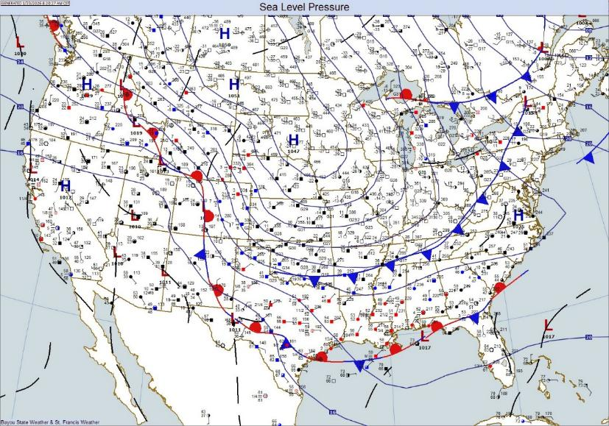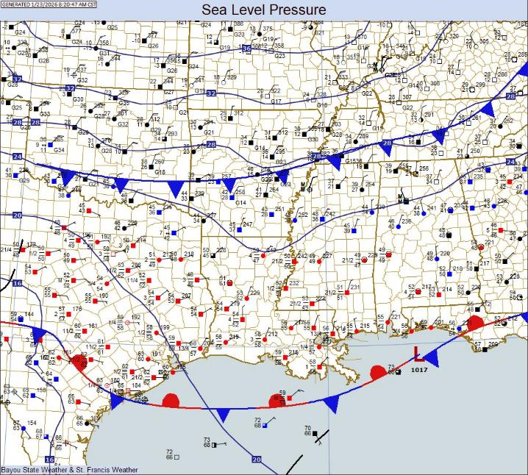
Surface Maps for 8AM CST 1/24/26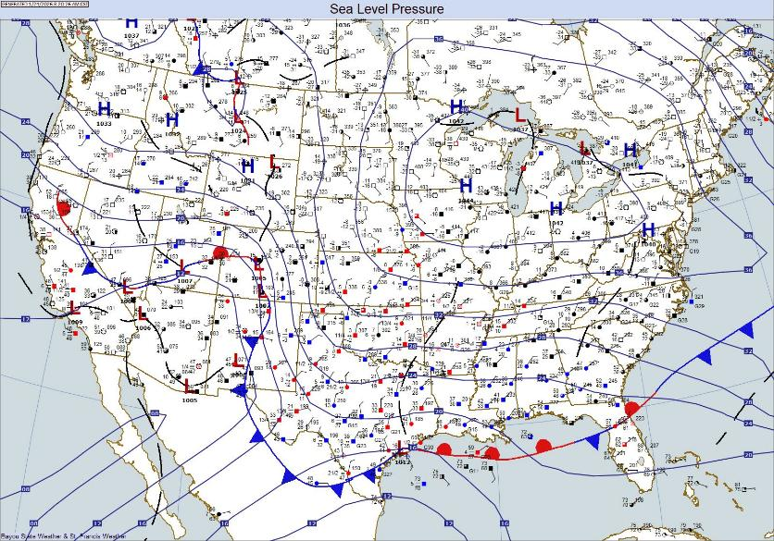
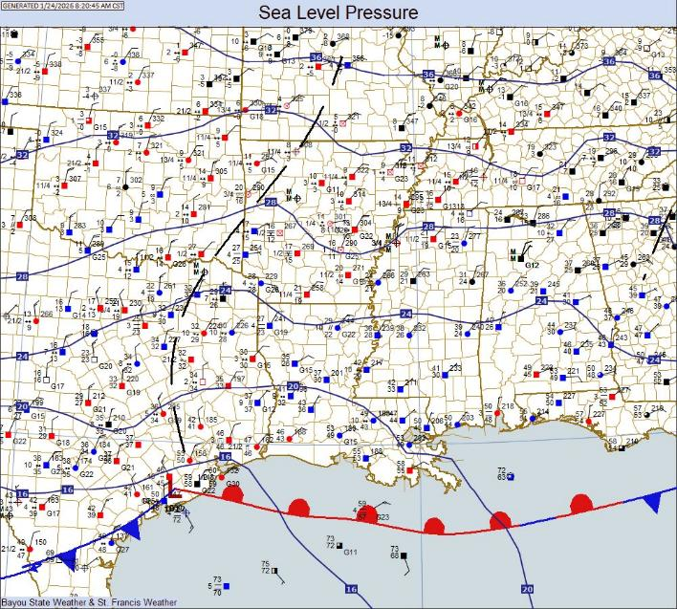
Forecast Ice and Sleet Accumulations
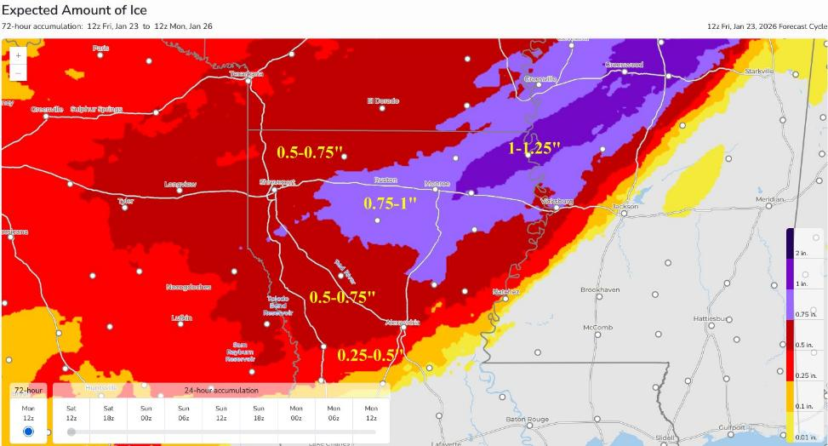

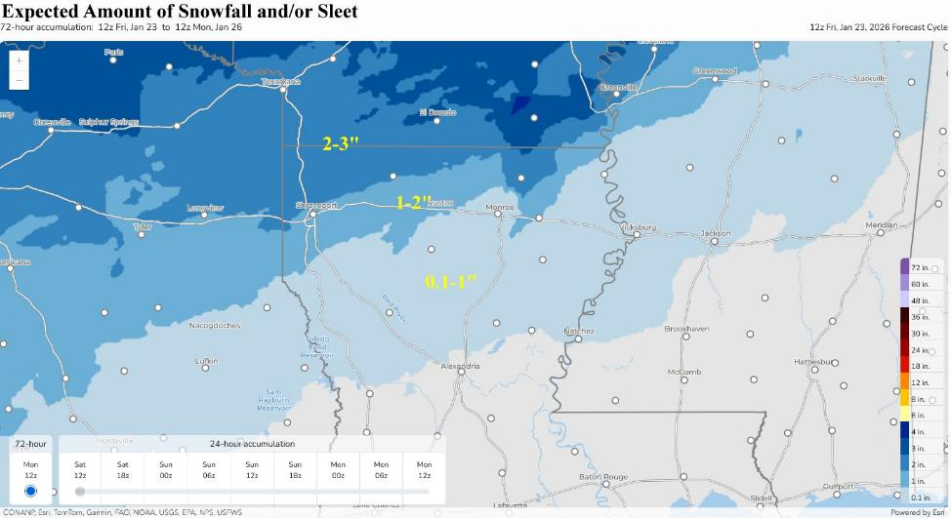

Actual Ice and Sleet Accumulations – National Weather Service Shreveport
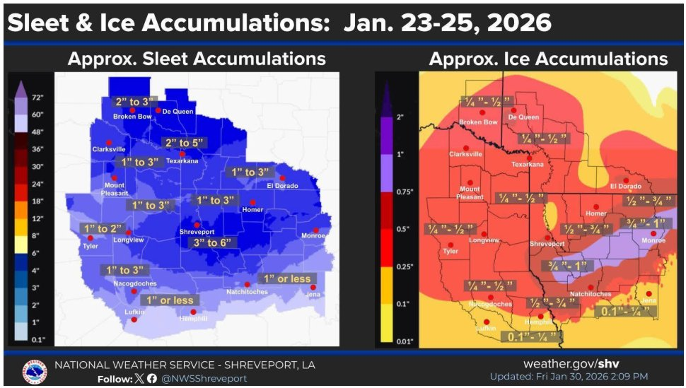

Power Outage Map as of 1/27/26 at 6AM CST
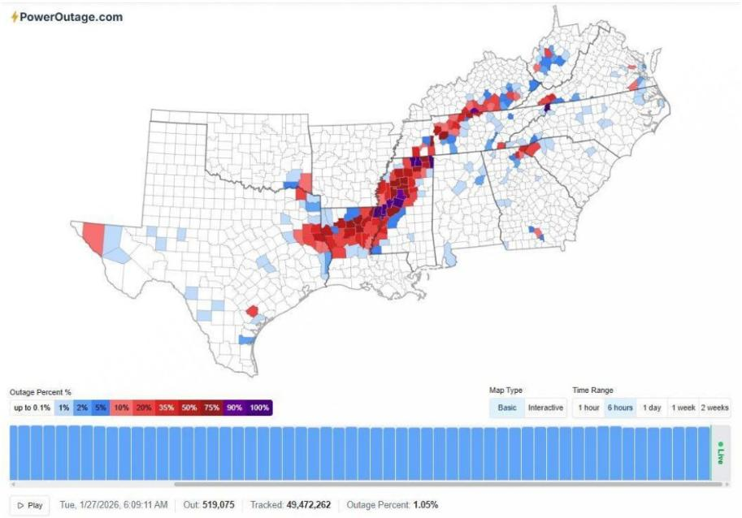
State of Emergency Declaration
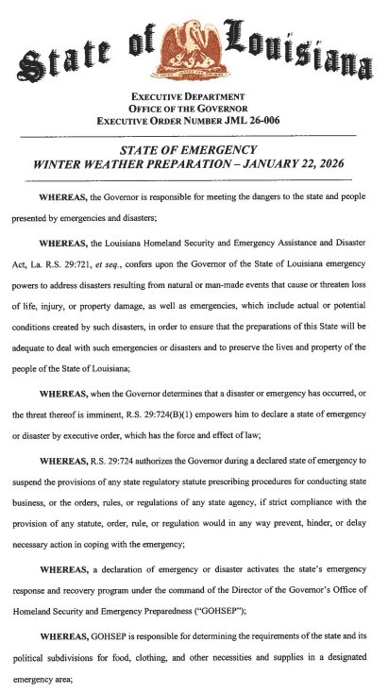

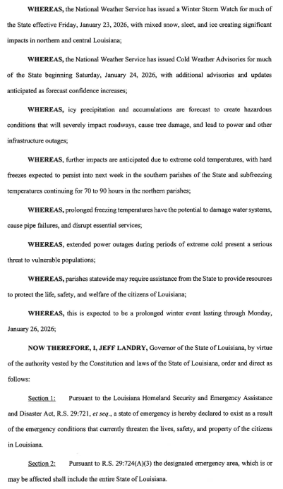

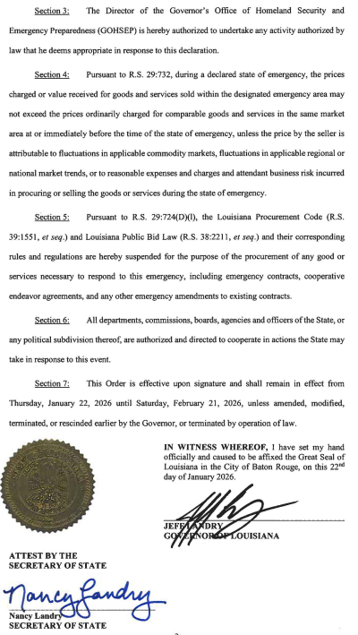

Letter to President Trump from Louisiana Senators and Members of Congress
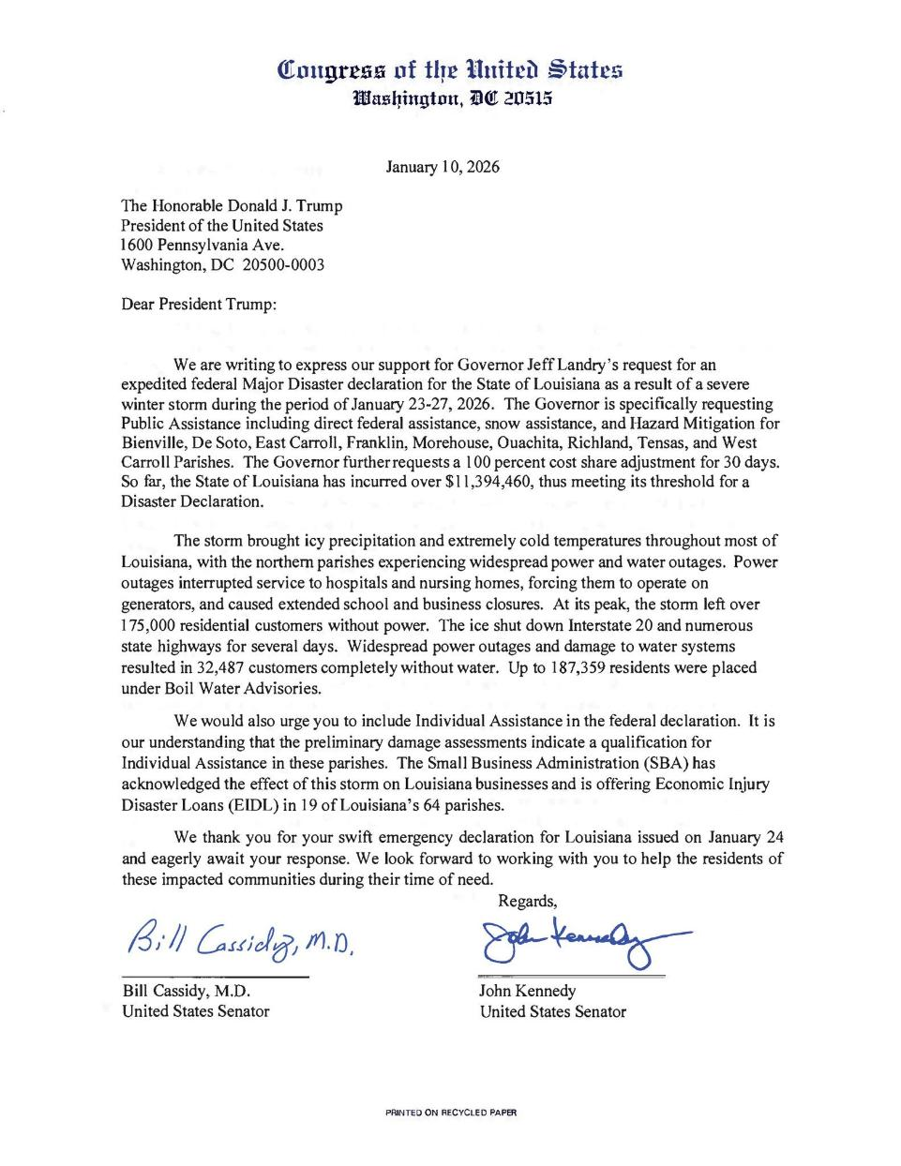
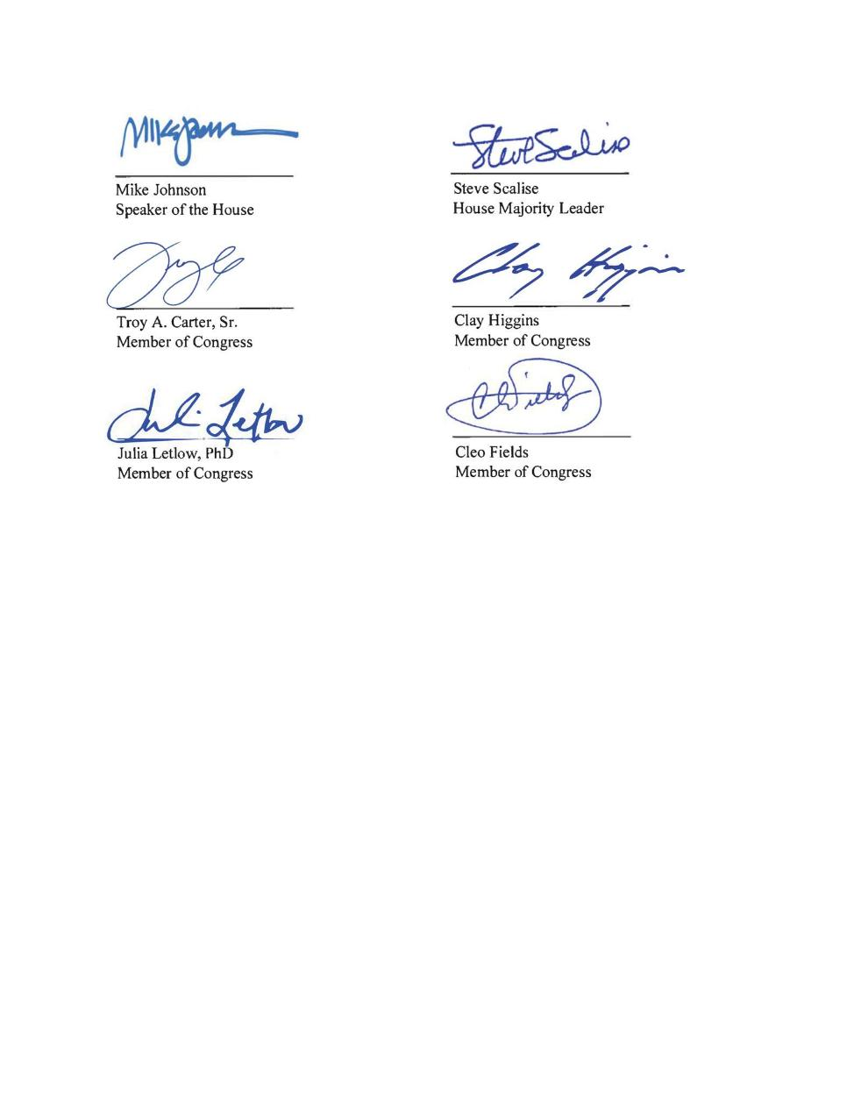

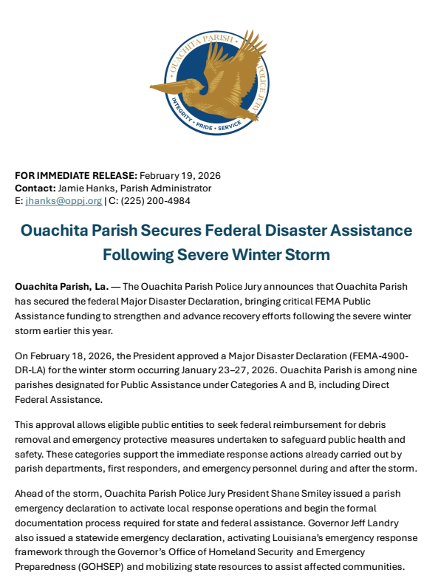

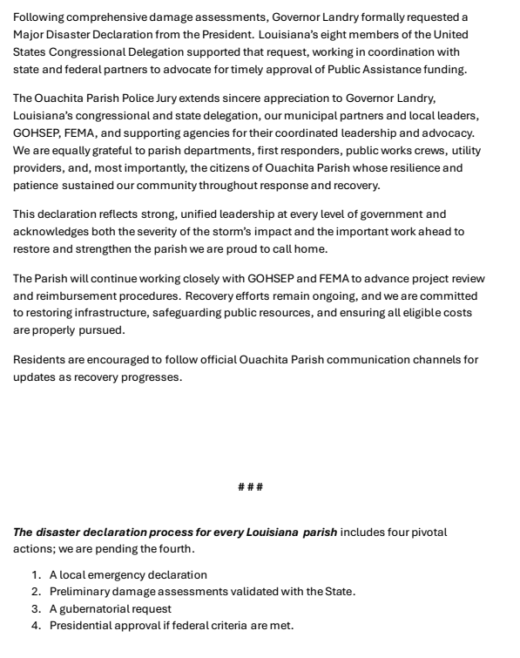

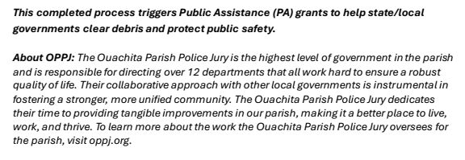
Acknowledgements

National Weather Service – Shreveport, Louisiana
Plymouth Weather (https://vortex.plymouth.edu/)
University of Wyoming (https://weather.uwyo.edu/)
St. Francis Weather (https://stfrancisweather.com)
Tom Malmay – Malmay and Associates
Bayou State Weather (https://bayoustateweather.com)
Burt Green/WeatherUP (https://www.facebook.com/BurtGreenWX)
KSLA-TV (https://www.ksla.com)
Ouachita Parish Police Jury
PowerOutage.com
Entergy

